Short Answer

**RTT**:

1. Percent of websites that do not respond: 0.22. Percent with at least one failed ping: 0.31. Median RTT Graph:

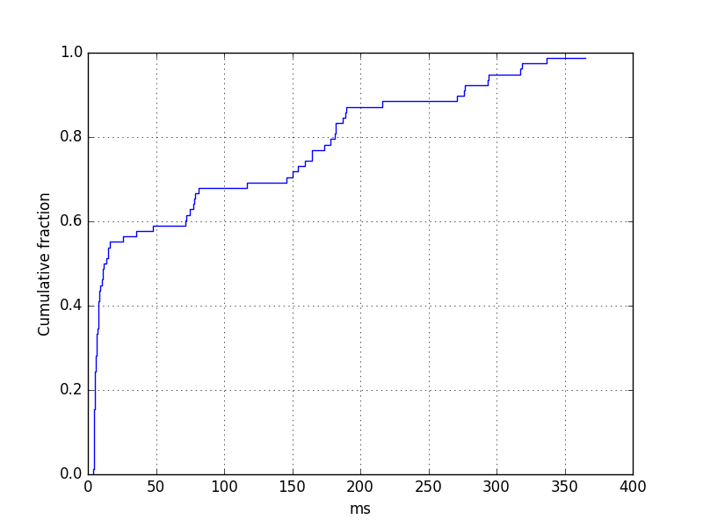

1. todayhumor.co.kr

median_rtt: 92.409

drop_rate: 0.2

max_rtt: 197.281

google.com

median_rtt: 4.909

drop_rate: 0.2

max_rtt: 239.982

taobao.com

median_rtt: 257.448

drop_rate: 11.4

max_rtt': 785.063

zanvarsity.ac.tz

median_rtt: 335.078

drop_rate: 0.2

max_rtt: 1005.17

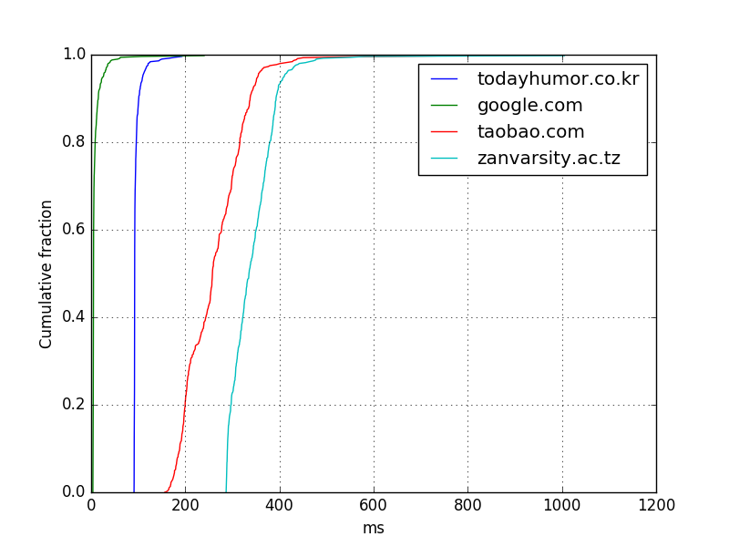

1. google.com multiplier is 25.956807777. zanvarsity.ac.tz multiplier is 6.2710604307. Queueing delays contribute to the extra delay in ping times as compared to speed of light. Speed of light is not constant in all mediums, i.e. we assumed speed of light in a vacuum, whereas it may travel through different mediums such as glass, metal, etc.

**Routing:**

**DNS:**

1. Average Root TTL 489955.44799999992

Average TLD TTL 172800.0

Average Other TTL 111838.71415629037

Average Terminating TTL 7955.1000000000004

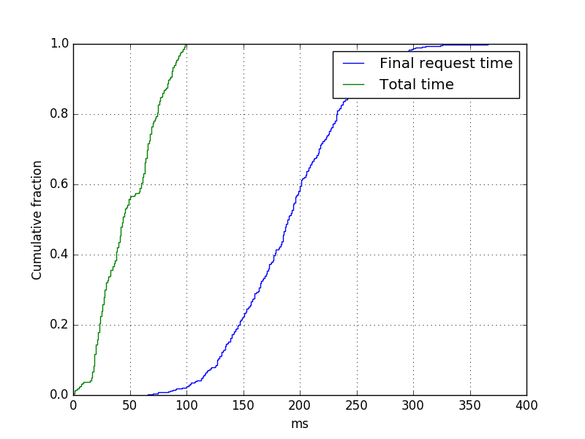

1. Difference in DNS response with one-hour difference (55, 56). 55 change within the first trial, 59 change in total.
2. Difference in DNS response with server from Makati (55, 78)
3. The reason for different DNS server being returned is to allow for load balancing, distributing the loads to different providers
4. It would have been much faster because wouldn’t have to resolve all requests iteratively, instead going directly to the server. This is evident from seeing as the average get times for +trace argument in place is 382.18 ms, whereas from the Makati server it is 206.99 ms